24th August Pratical

1. Vertical scaling

a) to apply vertical scaling we need to stop the istance

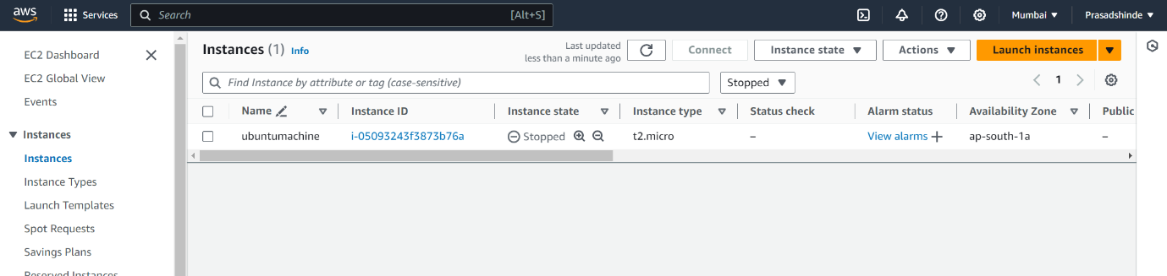

b)Change it into t2.small

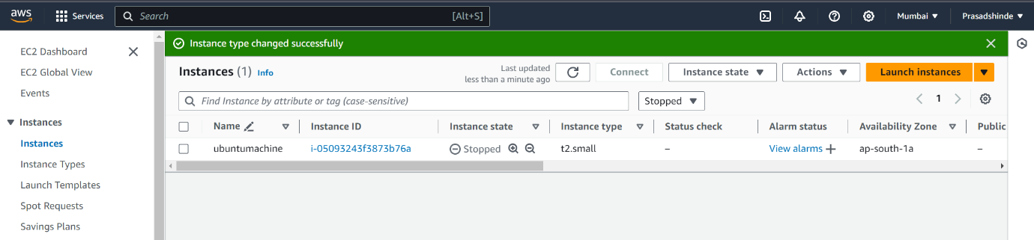

c)create one volume

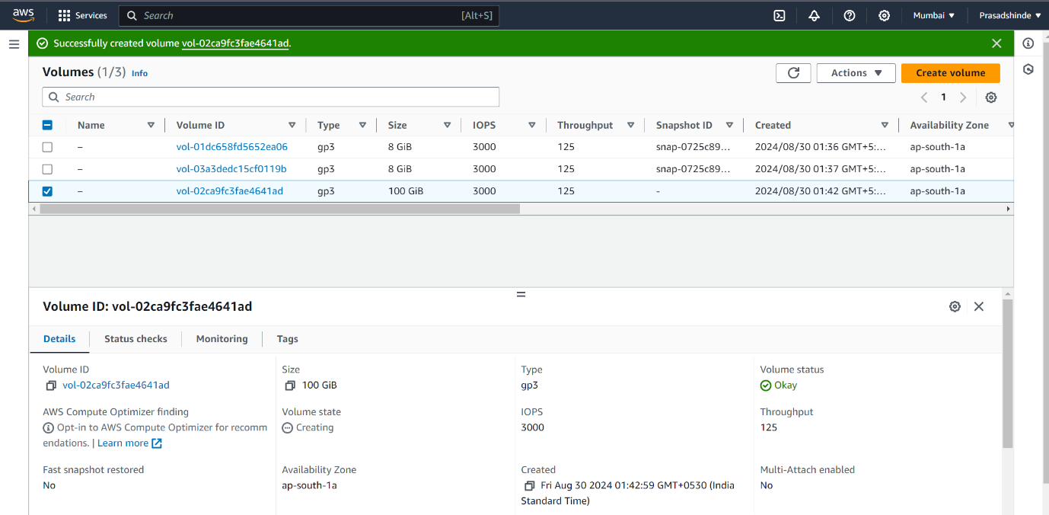

d)attach EBS volume to instance

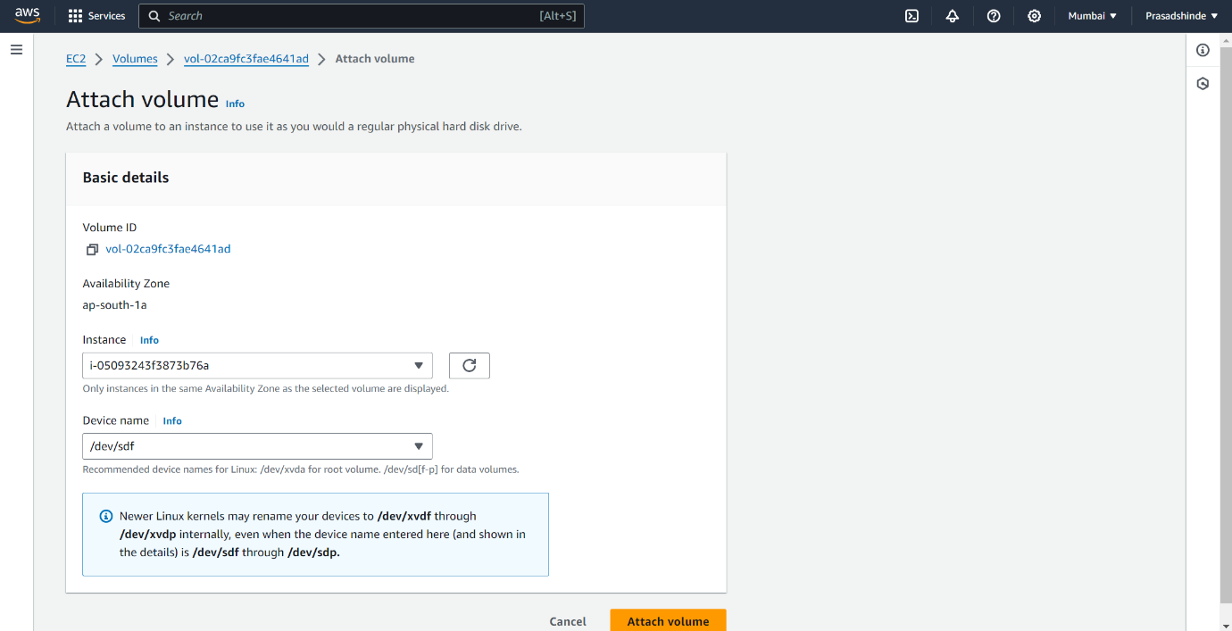

Successfully Attach the volume to instance

